Batch: B2 Roll No.: 16010121200

Experiment / assignment / tutorial No. 5

Grade: AA / AB / BB / BC / CC / CD /DD

Signature of the Staff In-charge with date

Experiment No.: 5

TITLE: Flow control Mechanism: Go-Back- N ARQ Sliding Window Protocol using Socket programming
__________________________________________________________________________
AIM: Implementation of Flow Control Mechanism: Stop and Wait ARQ and Go-Back- N Sliding Window Protocol ARQ using sockets.

Expected Outcome of Experiment:
CO:
__________________________________________________________________________
Books/ Journals/ Websites referred:
- A. S. Tanenbaum, “Computer Networks”, Pearson Education, Fourth Edition
- B. A. Forouzan, “Data Communications and Networking”, TMH, Fourth Edition
__________________________________________________________________________
Pre-Lab/ Prior Concepts:
Java Socket Programming, Flow Control, Go-Back-N, Stop and Wait
__________________________________________________________________________
New Concepts to be learned: Window Flow Control __________________________________________________________________________

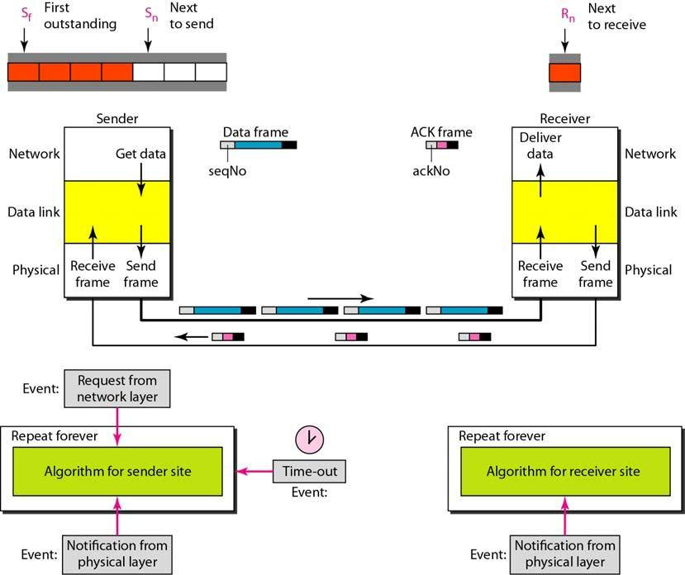
Design of Go-Back-N ARQ

- Take data from user about how many bit window is case of go back n and selective repeat.

- Generate frames randomly and show the transmission

- Generate the random number for the frame to be lost.

- For Go-Back-N transmit all the frames after that number till max number

- For Selective repeat transmit the selected frame which is not received by the receiver.

IMPLEMENTATION: (printout of code)

Code for server (sender):
import time, socket, os
import numpy as np
import multiprocessing as mp

def my_timer(time_queue, nextSeqNum):
# print(f"Started {nextSeqNum}")
time.sleep(7)
# print(f"Timeout {nextSeqNum}")
time_queue.put(f"Timeout {nextSeqNum}")

if __name__ == '__main__':
try:
s = socket.socket(socket.AF_INET, socket.SOCK_STREAM)
print("Socket successfully created!")
except socket.error as err:
print("socket creation failed with error %s" %(err))
os._exit(1)

host = socket.gethostname()
ip = socket.gethostbyname(host)
print("Host:", host)
print("IP:", ip)
port = 12345
s.bind((host, port))
print("Socket binded to port %s" %(port))

s.listen(1)
print ("Listening for incoming connections...")

conn, addr = s.accept()
print("\nReceived connection from", addr[0])
client = conn.recv(1024)
client = client.decode()
print(client, "is connected!")
conn.send(host.encode())

frames = int(input("\nEnter number of frames to be sent: "))
N = int(input("Enter size of sender window: "))

sendBase = 0
nextSeqNum = 0

timers = []
time_queue = mp.Queue()

while True:
window = [i for i in range(sendBase, sendBase + N) if i < frames]
if window != []:
print("\nSender window:", window)
if nextSeqNum in window:
print("Sending packet", nextSeqNum)
message = f"Packet {nextSeqNum}"
time.sleep(0.5)
conn.send(message.encode())
timer = mp.Process(target=my_timer, args=(time_queue, nextSeqNum))
timer.start()
timers.append((nextSeqNum, timer))
nextSeqNum += 1

try:
conn.settimeout(3)
ack = conn.recv(1024)
ack = ack.decode()
ack_no = int(ack[-1])
if np.random.choice([0,1], p = [0.25, 0.75]): # ACK received?
print(f"ACK {ack_no}")
sendBase = ack_no
for timer in timers:
if timer[0] < ack_no:
timer[1].terminate()
else:
print(f"Ack {ack_no} lost")
except TimeoutError:
pass

# print(time_queue.qsize())
while not time_queue.empty():
timeout_msg = time_queue.get()
print(f"Frame {timeout_msg[-1]} timeout.")
for timer in timers:
timer[1].terminate()
timers = []
nextSeqNum = sendBase
else:
print("\nAll data sent, closing connection...")
message = "FIN"
conn.send(message.encode())
fin_ack = conn.recv(1024)
fin_ack = fin_ack.decode()
if fin_ack == "FIN":
break

s.close()
print("Connection closed!")

Code for client (receiver):
import time, socket, os
import numpy as np

try:
s = socket.socket(socket.AF_INET, socket.SOCK_STREAM)
print("Socket successfully created!")
except socket.error as err:
print("socket creation failed with error %s" %(err))
os._exit(1)

host = socket.gethostname()
ip = socket.gethostbyname(host)
print("Host:", host)
print("IP:", ip)

host_ip = input("\nEnter server IP address: ")
port = 12345
print("Connecting to server at port %s..." %(port))
s.connect((host, port))
s.send(host.encode())
srv_name = s.recv(1024)
srv_name = srv_name.decode()
print(f"Connected to server {srv_name}!")

nextSeqNum = 0

while True:
try:
message = s.recv(1024)
message = message.decode()
if message != "FIN":
print("\nReceiver Window: ", nextSeqNum)
if np.random.choice([0,1], p = [0.25, 0.75]): # Frame reveived?
frame_no = int(message[-1])
print(f"Received frame {frame_no}")
if frame_no == nextSeqNum: # Expected frame received?
nextSeqNum += 1
ack = f"ACK {nextSeqNum}"
print(f"Sending ACK {nextSeqNum}")
s.send(ack.encode())
else:
print("Frame discarded.")
else:
print("Frame lost")
else:
print("\nAll data received, closing connection...")
fin_ack = "FIN"
s.send(fin_ack.encode())
s.close()
print("Connection closed!")
break
except TimeoutError:
print("Conection closed.")
s.close()
except ConnectionResetError:
print("Connection closed by server.")
os._exit()

Output:
Server: Client:
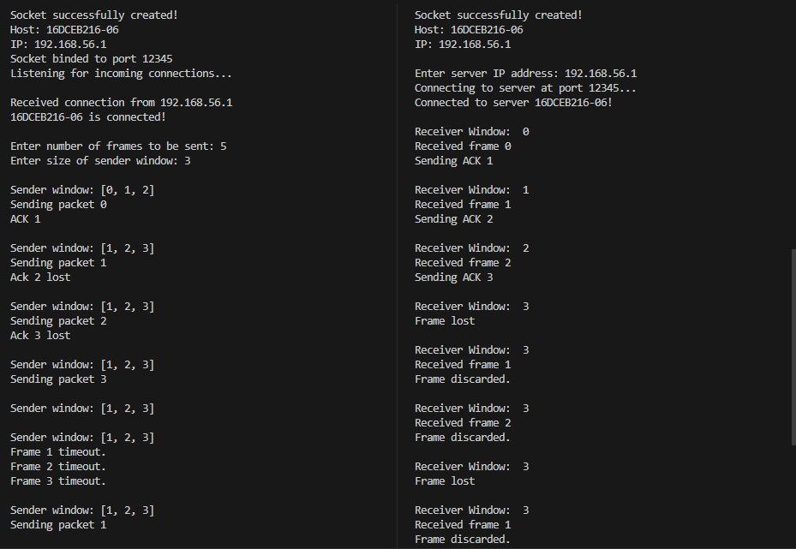
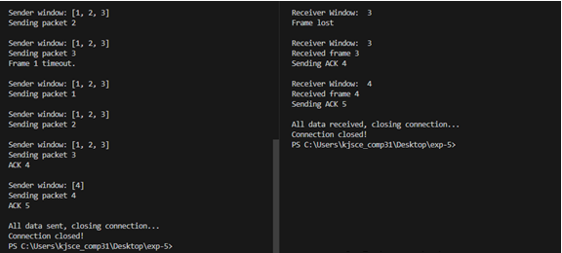

CONCLUSION:

Understood Go-back-N protocol and successfully implemented it in python using sockets and multiprocessing.

Post Lab Questions

- Compare Go-Back-N and Stop and Wait.
Key | Stop and Wait protocol | Go-back-N protocol
Sender Window size | Sender Window size is 1. | Sender Window size is N.
Receiver Window size | Receiver Window size is 1. | Receiver Window size is 1.
Minimum sequence number | Minimum sequence number is 2. | Minimum sequence number is N+1, where N is the number of packets sent.
Efficiency | Efficiency = $\frac{1}{1+2a}$  Where ‘a’ is ratio of propagation delay vs transmission delay. | Efficiency = $\frac{N}{1+2a}$  Where ‘a’ is ratio of propagation delay vs transmission delay and N is number of packets sent.
Acknowledgement type | Acknowledgement is individual. | Acknowledgement is cumulative.
Retransmissions | Only 1 packet is retransmitted. | N packets are retransmitted.

- What is Flow Control and why it is necessary?
Flow control mechanisms can be classified by whether or not the receiving node sends feedback to the sending node. Flow control is important because it is possible for a sending computer to transmit information at a faster rate than the destination computer can receive and process it.
- The maximum window size for data transmission using the selective reject protocol with n-bit frame sequence numbers is
a) 2n b) 2n-1 c) 2n-1 d)2n-2

Date: 23/10/2023 Signature of Faculty In-charge

